1. Process Principles

These three sub-chapters provide summaries in connection with compliance cases. The summaries are designed to reflect the different aspects: the process, main messages for the conduct and to answer the most obvious practical questions.

# 1. Process Overview

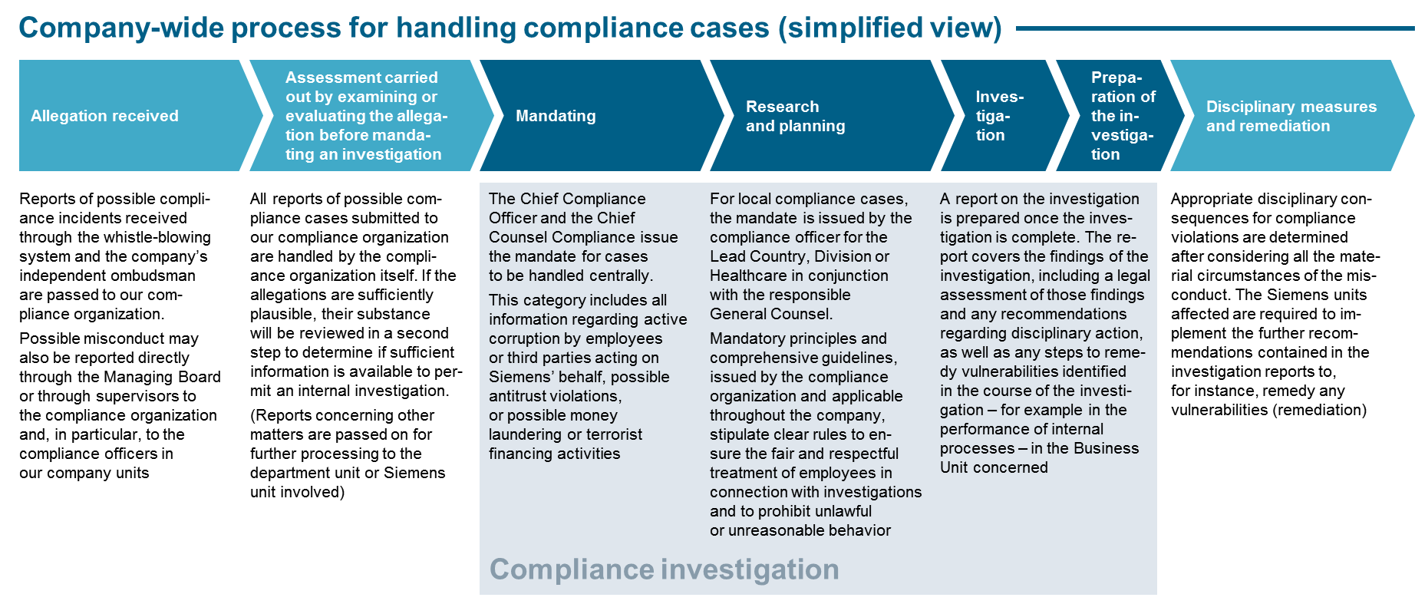

*Chart 1: "Process Overview"*

# 2. Do’s and Don’t’s

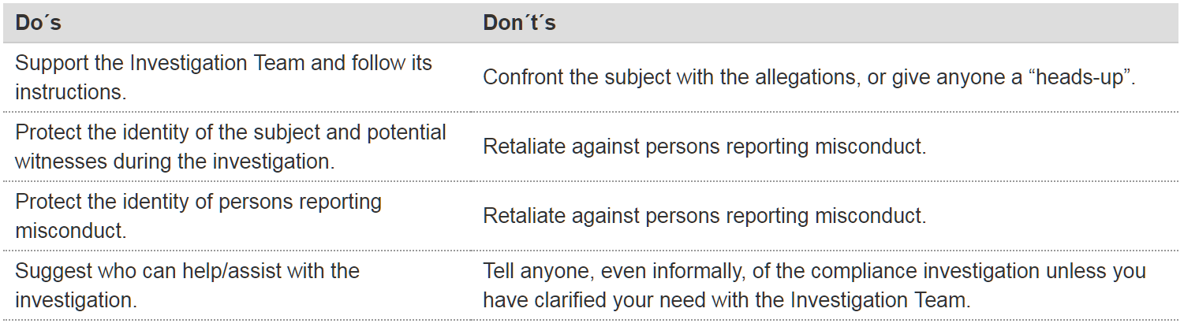

*Chart 2: “Do’s and Don’t’s*

# 3. Questions & Answers

* **What is the difference between a Compliance Investigation and an audit?**

Investigation is the process of inquiring into a matter of possible individual misconduct through research, follow-up, study, or formal procedure of discovery, in order to establish the facts of this matter. Investigating means to examine a misconduct, crime, problem, statement, etc. in an objective and independent manner with either exculpatory or incriminatory results.

**Internal auditing is** an independent, objective assurance and consulting activity with focus on an organization’s operations. It helps an organization accomplish its objectives by offering a systematic, disciplined approach to evaluate and improve the effectiveness of risk management, control, and governance processes.

* **When is a Compliance Investigation conducted at Siemens?**

All Compliance Investigations at Siemens will be conducted following the receipt of allegations, which, after a thorough plausibility check by Compliance Regulatory and Investigation, will result in the authorization of a mandate, either by the Chief Counsel Compliance and the Chief Compliance Officer for high risk cases, or by the responsible Compliance Officer together with the responsible lawyer from Compliance Regulatory and Investigation for all other cases.

* **What is the objective of a Compliance Investigation?**

The objective of a Compliance Investigation is to establish the facts pertaining to an allegation of wrongdoing.

* **How can Siemens employees be assured that they will be treated fairly?**

On basis of Siemens Circular No. 226, all Compliance Investigations will be carried out according to an established process and free of any interference. Once the facts have been established a legal evaluation will be carried out and both are recorded in a report. Employees may also rely on the principles enumerated in the following question.

* **What are the four most important principles in Compliance Investigations?**
  + The Investigation Team shall respect the principle of confidentiality in an investigation.
  + The Investigation Team shall respect both the spirit and the letter of the law within each jurisdiction where Siemens conducts business.
  + The Investigation Team shall respect all rights accorded to the individual by custom and law in upholding the presumption of innocence.
  + The Investigation Team shall protect the identity of persons reporting misconduct to the best extent possible.
* **Who will receive the investigation report?**

According to the given process, Compliance Investigations reports are addressed in “high” risk cases to the Chief Compliance Officer, in other cases to the respective Compliance Officer. Furthermore, a distribution list is recommended in the report following the “need-to-know principle”.

* **Will the subject of a Compliance Investigation be informed about the investigation results?**

Yes - if the investigation did not substantiate the allegation, the subject will receive an official clearance letter issued by Regulatory Compliance Legal. If the allegation is substantiated by the investigation, the subject will receive notice of a pending disciplinary hearing. However, the subject will not be provided with the investigation report.

# 4. History of changes

|  |  |  |
| --- | --- | --- |
| **Date** | **Author** | **Major changes of binding content** |
| April 1, 2019 | Bernd Plagemann | Discontinuation of the differentiation between central and local cases. |

# 5. Contacts

* Please [contact](https://intranet.for.siemens.com/cms/059/en/about/org/Pages/compliance_organization.aspx) Compliance Regulatory and Investigation or the Case Handling hub in your region for further questions.
* Corporate Governance Owner

[Anette Kraus (LC CO IR)](https://soc.siemens.cloud/profile/Z002K99S)